Password Protecting Personally Identifiable Information (PII)

This instruction document provides information on how to password-protect documents created in Microsoft Word 2007, Symphony (comes with Lotus Notes 8.5.x), and Open Office.

Microsoft Word 2007

1. Create a new document.

2. Save As > Word 97-2003 Document
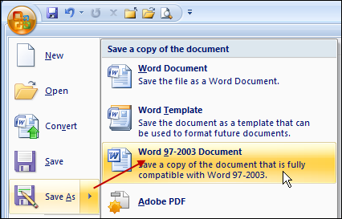

3. Provide a File name > Save as type: Word 97-2003 Document (*.doc). Click on Tools > General Options.
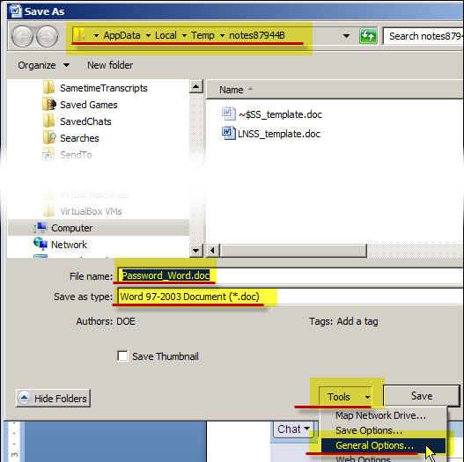
4. Enter a password in Password to open. To make the document read-only, click on the box for Read-only recommended.
If you want to give the recipient of the file the option to edit the document, then add a password to Password to modify.
Click on OK.
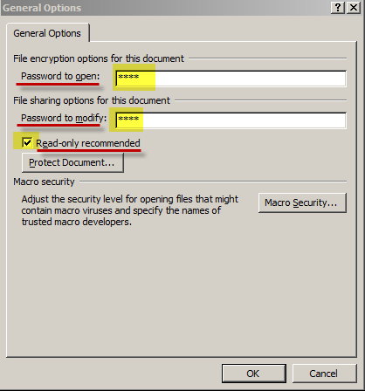

Symphony
Comes as part of Lotus Notes version 8.5.x.
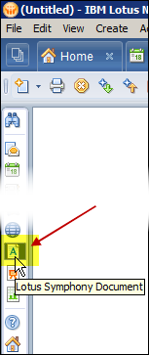

1. Create a New document.

2. Save with a password. Go to File > Save As with Password…
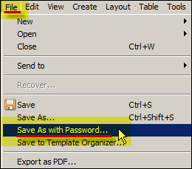

3. Enter a File name > Save as type: Microsoft Word 97-2003(*.doc). The file extension changes to *.doc.
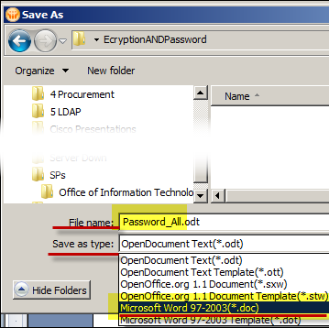

4. Enter password and Re-enter password. See note: Passwords must be at least 5 characters long and are case-sensitive. Passwords cannot be recovered. Click on OK.
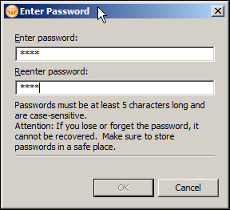

Open Office 3.3.0 – Save as *.doc
1. Create a New document.
2. Go to File > Save As…
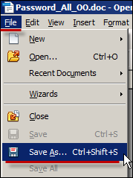

3. Enter a File name > Save as type: Microsoft Word 97-2003(*.doc). The file extension changes to *.doc. Click on Save.
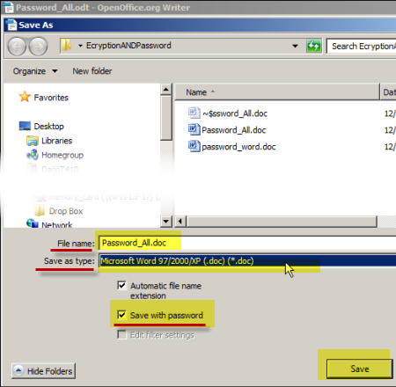
4. Enter password to open and Confirm password. See note: Passwords cannot be recovered.
If you want to lock the document and prevent editing, click on the box for Open file read-only. Click on Save.
To allow editing, uncheck the box for Open file read-only, and Enter password to allow editing > Confirm password.
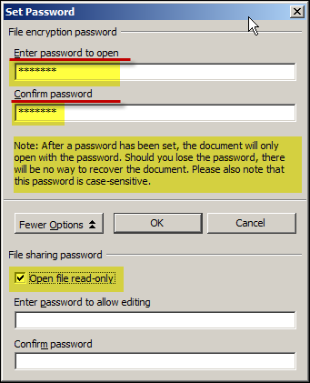

Export as PDF – Symphony and Open Office
Both Symphony and Open Office can export into PDF format and password-protect the file. In both applications go to File > Export as PDF.

The advantage to saving as a PDF file is that Windows, Macs, and Linux can open the file as long as they have the free Adobe Reader application. Additionally with the Mac, the native Preview application can read PDF files.

Export as PDF – Microsoft Word
The Adobe Acrobat application needs to be purchased in order to convert Word documents in PDF files.

